Solution Architecture

Date | 1 July 2026
Team ID | xxxxxx
Project Name | Book A Doctor
Maximum Marks | 5 Marks

Solution Architecture Diagram:

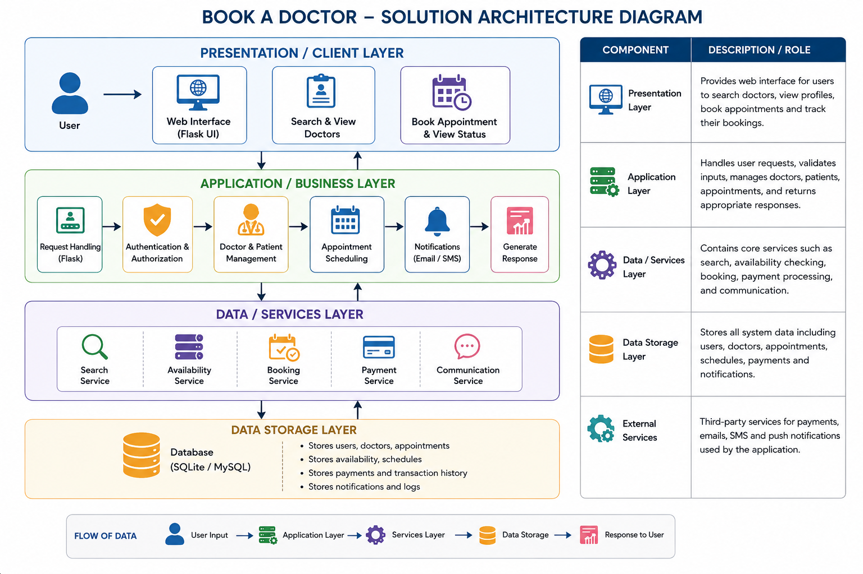
Component Description Table

Component Name | Description / Role in Architecture | Technologies Used
Presentation Layer | Provides a user-friendly web interface for patients and doctors to register, log in, search doctors, view profiles, book appointments, and manage bookings. | HTML5, CSS3, Bootstrap, JavaScript
Application Layer | Handles user requests, authentication, appointment scheduling, doctor availability management, business logic, and communication between the frontend and database. | Python, Flask
Database Layer | Stores patient information, doctor details, appointment schedules, booking history, user credentials, and feedback securely. | SQLite / MySQL
Authentication Layer | Verifies user credentials, manages login sessions, and controls access for patients, doctors, and administrators. | Flask-Login, Werkzeug Security

